**MIGRANTS SMUGGLED BY LEISURE BOATS ON ADRIATIC SEA: 8 ARRESTED IN GREECE AND ITALY**

*12 December 2019*

*Press Release*

[Print](https://www.europol.europa.eu/print/newsroom/news/migrants-smuggled-leisure-boats-adriatic-sea-8-arrested-in-greece-and-italy)[PDF](https://www.europol.europa.eu/printpdf/newsroom/news/migrants-smuggled-leisure-boats-adriatic-sea-8-arrested-in-greece-and-italy)

* [E-mail](mailto:?subject=Migrants%20smuggled%20by%20leisure%20boats%20on%20Adriatic%20Sea%3A%208%20arrested%20in%20Greece%20and%20Italy%20%7C%20Europol&body=https%3A%2F%2Fwww.europol.europa.eu%2Fnewsroom%2Fnews%2Fmigrants-smuggled-leisure-boats-adriatic-sea-8-arrested-in-greece-and-italy)
* [Facebook](http://www.facebook.com/share.php?u=https%3A%2F%2Fwww.europol.europa.eu%2Fnewsroom%2Fnews%2Fmigrants-smuggled-leisure-boats-adriatic-sea-8-arrested-in-greece-and-italy&t=Migrants%20smuggled%20by%20leisure%20boats%20on%20Adriatic%20Sea%3A%208%20arrested%20in%20Greece%20and%20Italy%20%7C%20Europol)
* [Twitter](https://twitter.com/intent/tweet?url=https%3A%2F%2Fwww.europol.europa.eu%2Fnewsroom%2Fnews%2Fmigrants-smuggled-leisure-boats-adriatic-sea-8-arrested-in-greece-and-italy&text=Migrants%20smuggled%20by%20leisure%20boats%20on%20Adriatic%20Sea%3A%208%20arrested%20in%20Greece%20and%20Italy%20%7C%20Europol)
* [LinkedIn](http://www.linkedin.com/shareArticle?mini=true&url=https%3A%2F%2Fwww.europol.europa.eu%2Fnewsroom%2Fnews%2Fmigrants-smuggled-leisure-boats-adriatic-sea-8-arrested-in-greece-and-italy&title=Migrants%20smuggled%20by%20leisure%20boats%20on%20Adriatic%20Sea%3A%208%20arrested%20in%20Greece%20and%20Italy%20%7C%20Europol&ro=false&summary=&source=)

THIS NEWS/PRESS RELEASE IS ABOUT [FACILITATION OF ILLEGAL IMMIGRATION](https://www.europol.europa.eu/crime-areas-and-trends/crime-areas/facilitation-of-illegal-immigration)

[*View all crime areas*](https://www.europol.europa.eu/crime-areas-and-trends/crime-areas)

About 150 migrants, some of which children, were smuggled in unsafe and overcrowded vessels

[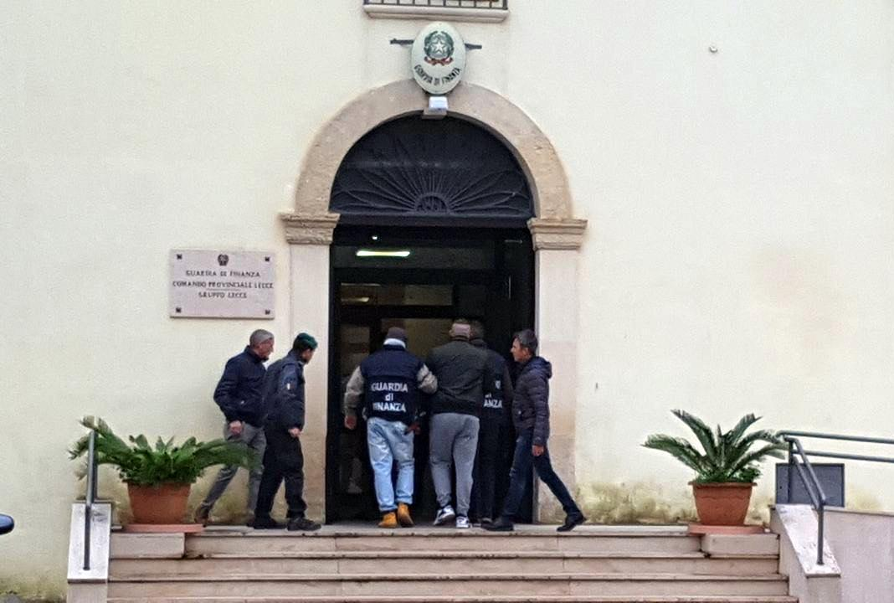](https://www.europol.europa.eu/sites/default/files/styles/europol_extra_large/public/images/1_32.jpg?itok=OjIRw4Mv)

Law enforcement authorities from Greece and Italy, supported by Europol and [Eurojust](http://www.eurojust.europa.eu/pages/home.aspx), have dismantled a large [organised crime group smuggling migrants](https://www.europol.europa.eu/crime-areas-and-trends/crime-areas/facilitation-of-illegal-immigration) by leisure boats / pleasure crafts via the Adriatic Sea.

On the action day, law enforcement authorities carried out 13 house searches and arrested 8 individuals of Greek, Italian and Middle Eastern origin suspected to be members of the criminal network. Investigations are still ongoing in both countries.

Active since 2018, the organised criminal group is suspected of smuggling around 150 migrants from the west of Greece via the Strait of Corfu to the southern Italian coast between Otranto and Lecce. The migrants were paying up to €6 000 to travel about 12 hours in leisure boats sometimes as small as ten meters long. Children under 13 years old were among the migrants smuggled this way by the criminal group.

Europol has supported this complex cross-border investigation with the deployment of experts from its [European Migrant Smuggling Centre](https://www.europol.europa.eu/about-europol/european-migrant-smuggling-centre-emsc). Europol facilitated the information exchange between concerned law enforcement and prosecution authorities and coordinated operational meetings. Europol also provided constant intelligence analysis on the wider phenomenon and case specific intelligence products.

On the action day, Europol participated in the coordination centre set-up at Eurojust. Europol supported the exchange of officers between Italy and Greece and deployed experts to support the field activities with cross-checking of operational information in real-time. Europol staff permanently deployed to the European Union Regional Task Forces in Athens and Catania supported this operation during the whole period of the investigation.